Interview for The Web 3 Connection exhibition, Calgary, Alberta, Oct. 11-12, 2025

<https://muultispace.com/TheWeb3Connection/c/1759847750522> **Web3 Connection**

# e W**John Thurman**

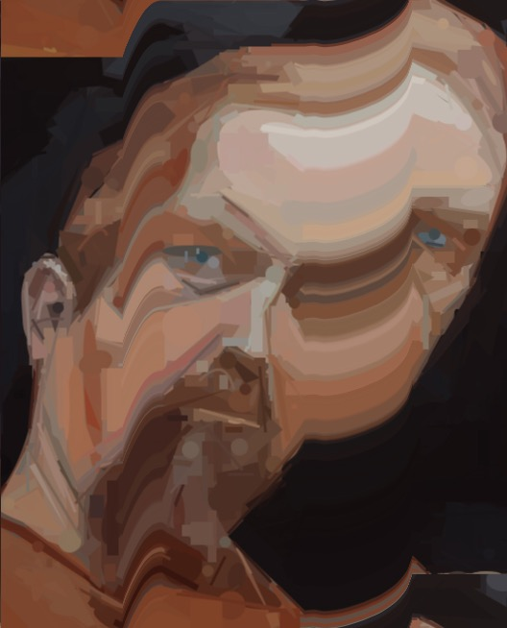

**John Thurman - he/him**

I've always made art, and started with more traditional meda: watercolor, acrylic, and oil painting. What matters to me is that I am able to make what I want to make when I want to make it.

**The Battle for Los Angeles**

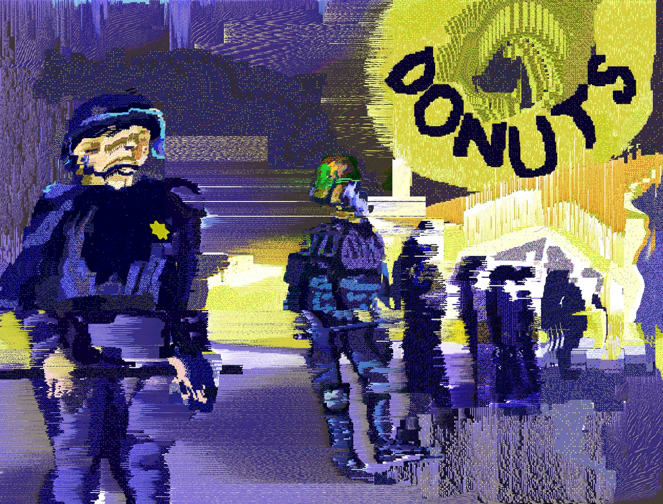

A thin blue line stands between anarchy and donuts. Digital painting.

**The frog can't take any more of this shit**

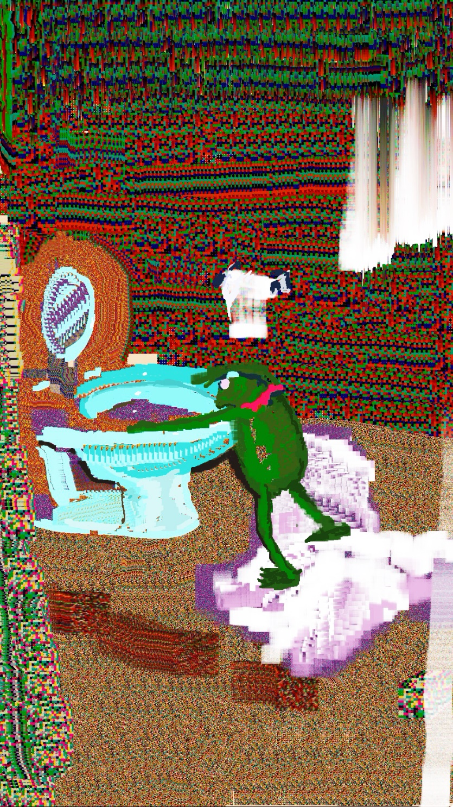

Digital meme painting. Memes are the lingua franca of online culture.

**Truth Soundings**

A digital painting expanded into video with AI. Includes sound.

**Moneygun**

This piece speaks for itself. Includes sound.

**80% Human**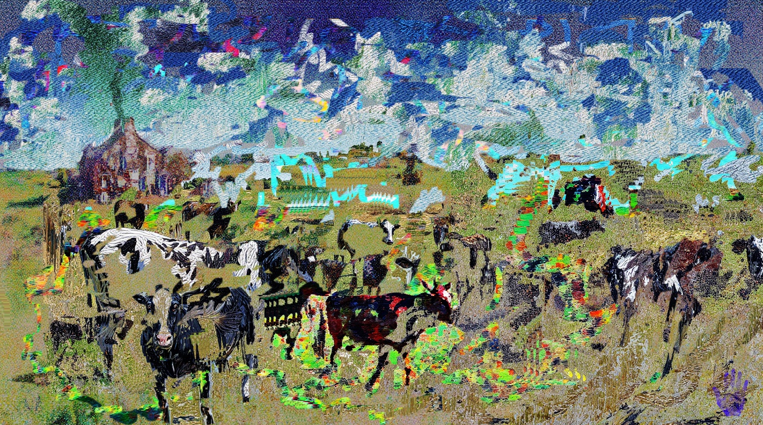

One of my many "glitchpaintings" combining AI with glitch for a painterly effect. All of these works are from 2025.

**What is your web3 story / what is your story with NFTs?**

I come from a background making physical art through traditional media, though I am largely self-taught. Some years ago I familiarized myself with cryptocurrency and not long thereafter intensified my emphasis on making art. By l

**How has NFTs, Web3, Blockchain, and/or Digital Ownership changed how you create artwork online? How has this space influenced your work?**

The blockchain gives my work a provenance that is immune to traditional methods of art forgery. With the finished work being digital, it can be displayed anywhere, or in many places, at virtually any time, so I do not have to think about logistics in the way the traditional art world does. And with many marketplaces being open to anyone who would sell works on them, I have great autonomy in deciding what to make. There are far fewer layers of middlemen between the artist and collector. Without explaining directly how the web 3 "space" has influenced me or my work, these are top factors at play.

**What are some challenges you've encountered when working with NFTs and Web3?**

The biggest challenge is artist discovery, which is also a function of the entire NFT community being a subsdiary of X.com, and hence at the mercy of its algorithm.

**Would your recommend this space to others? Why or why not?**

Yes, I would recommend it because it is preferable to the alternatives. But enter with your eyes open --- or as is said in web 3, DYOR (do you own research). My experience has been that every day is a struggle. But I'm also part of a worldwide digital art movement that is still more or less an underground subculture.

**How has approaching your artwork with NFTs, web3 and digital ownership changed how you connect with your audience and collectors?**

I would say, for reasons already gone into above, that traditional and digital art are separate worlds with some, relatively minimal, overlap. In web 3, we communicate directly with our audience of fellow artists and collectors through social media, through posting works and in direct messaging and chats.

eb3 Connection is a multi-screen exhibition that explores how artists, collectives, and communities are using blockchain, NFTs, and decentralized tools to create and connect in new ways. We’re inviting Web3 creators to submit artwork and personal reflections that highlight your creative journey in the space — how you’ve experimented, been empowered, faced challenges, and built community. This project is designed to shift public perception of Web3 — away from hype and speculation, and toward the real stories and practices shaping the future of art and ownership. While we do not currently have funding for artist honorariums, we are actively fundraising and this exhibit is part of a longer-term vision: to bring this collection to future events, conferences, and arts festivals, where further opportunities and support will Alberta) and online through MuultiSpace.com, allowing your work to be seen by new audiences, collaborators, and collectors around the world.